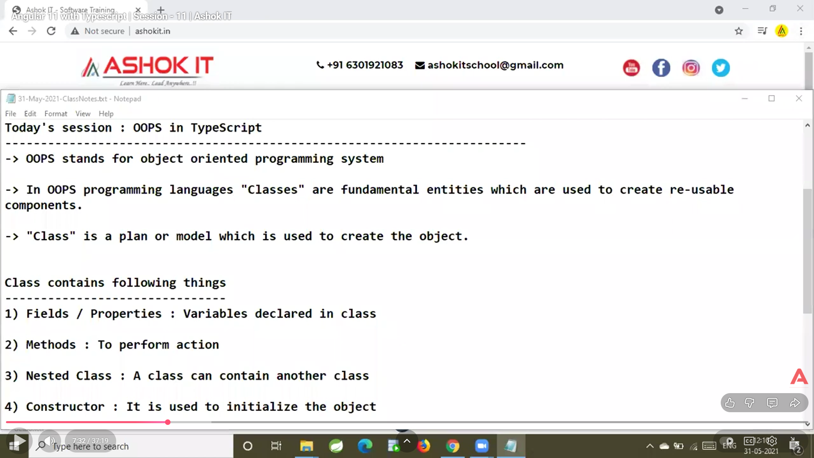
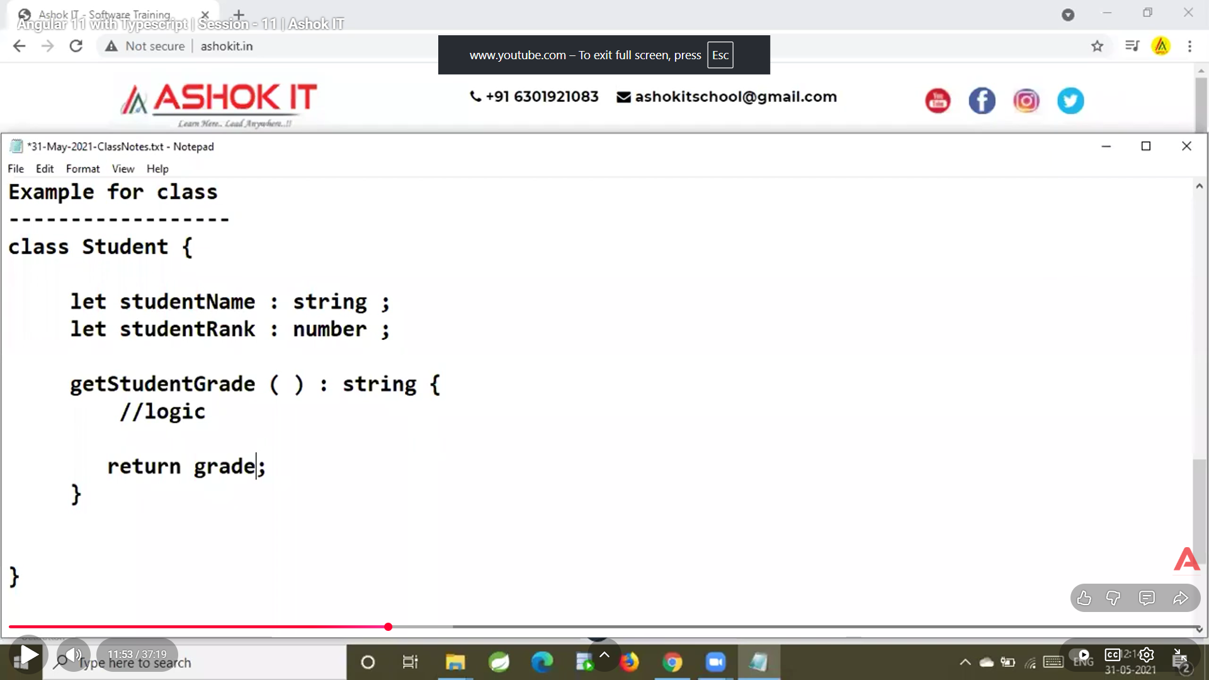
class Student {

studentName: string;
studentMarks: number;

constructor(name: string, marks: number) {
this.studentName = name;
this.studentMarks = marks;
}

getStudentMarks(): number {
return this.studentMarks;
}
}
class Student {

studentName: string;
studentMarks: number;

// constructor(name: string, marks: number) {
// this.studentName = name;
// this.studentMarks = marks;
// }

getStudentMarks(): number {
return this.studentMarks;
}
getStudentName():String{
return this.studentName;
}
}

// let s1=new Student("hamid",32);
// console.log(s1);

// let s2=new Student("hamid raza",77);
// console.log(s2);

let ob1=new Student();
ob1.studentName="Rohanwa chotaa";
ob1.studentMarks=77;

console.log(ob1);

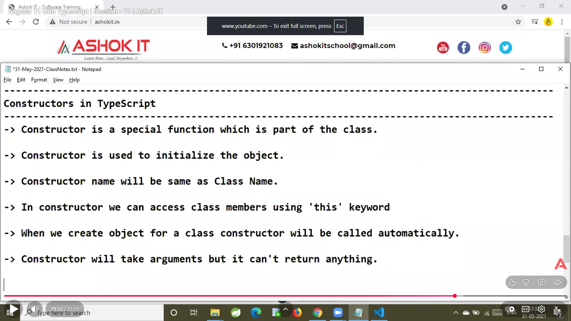
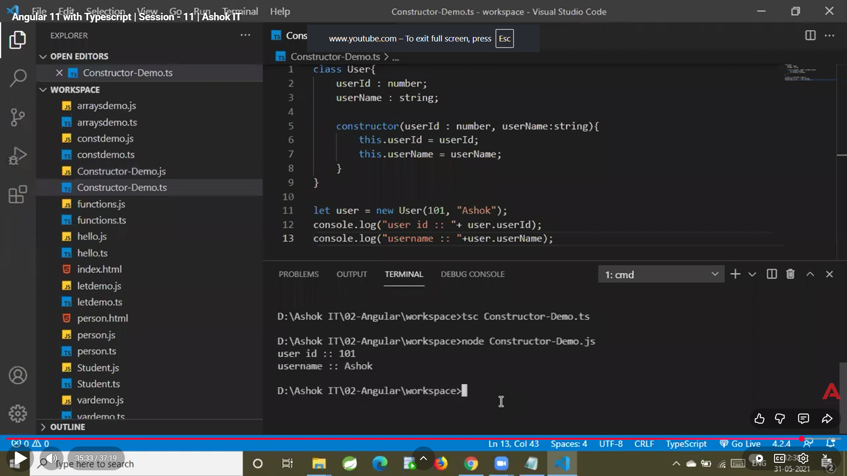
Here is the simplest and clearest explanation of OOP in TypeScript, with examples so easy that you will NEVER forget them.

🎯 OOP (Object Oriented Programming) in TypeScript
TypeScript supports all 4 Pillars of OOP:
- Encapsulation
- Inheritance
- Polymorphism
- Abstraction
Let’s break them down one by one with SUPER SIMPLE examples.

1️⃣ Encapsulation
Encapsulation = binding data + methods together, and restricting access using access modifiers.
✔ Use public, private, protected to control access.
Example:
class BankAccount {
private balance: number = 1000;

deposit(amount: number) {
this.balance += amount;
}

getBalance() {
return this.balance;
}
}

let acc = new BankAccount();
acc.deposit(500);
console.log(acc.getBalance()); // 1500
🧠 Remember:
Private data is hidden → accessed only using functions → this is encapsulation.

2️⃣ Inheritance
Inheritance = one class extends another class.
Example:
class Animal {
move() {
console.log("Animal is moving");
}
}

class Dog extends Animal {
bark() {
console.log("Dog is barking");
}
}

let d = new Dog();
d.move(); // Parent class method
d.bark(); // Child class method
🧠 Remember:
Child class = can use parent’s properties & methods.

3️⃣ Polymorphism
Polymorphism = same method name, different behavior.
Happens using method overriding.
Example:
class Shape {
area() {
return 0;
}
}

class Circle extends Shape {
area() {
return 3.14 * 5 * 5; // Overridden
}
}

class Square extends Shape {
area() {
return 4 * 4; // Overridden
}
}

let shapes: Shape[] = [new Circle(), new Square()];

shapes.forEach(s => console.log(s.area()));
🧠 Remember:
One method → many forms = polymorphism.

4️⃣ Abstraction
Abstraction = hiding complex details and exposing only important things.
Done using abstract classes.
Example:
abstract class Car {
abstract start(): void; // Only definition

stop() {
console.log("Car stopped");
}
}

class BMW extends Car {
start() {
console.log("BMW started");
}
}

let car = new BMW();
car.start();
car.stop();
🧠 Remember:
Abstract class = cannot create object directly.
Child must implement abstract method.

🎉 Bonus: Class & Object Basics
Class
A blueprint.
class Student {
name: string;
marks: number;

constructor(name: string, marks: number) {
this.name = name;
this.marks = marks;
}

getDetails() {
return `${this.name} scored ${this.marks}`;
}
}
Object
Created from a class.
let s = new Student("Hamid", 85);
console.log(s.getDetails());

🎁 Bonus: Interfaces in OOP
Interfaces define shape of an object (contract).
interface Person {
name: string;
age: number;
}

let p: Person = {
name: "Hamid",
age: 25
};

⭐ FINAL SUMMARY (Never Forget)
OOP Pillar | Meaning | Example
Encapsulation | Hide data | private balance
Inheritance | Child extends parent | Dog extends Animal
Polymorphism | Same method, different output | area() in Circle/Square
Abstraction | Only essential details | abstract class Car

If you want, I can give you:
✅ OOP Interview Questions for TypeScript
✅ Real project-level OOP examples
Just say "give interview questions" or "give project example"!

